Computer Architecture and Organization

Prashanth.S(19MID0020)

***Memory organization details***

The allotted range of physical address of specific functions of my System is displayed below. The “0x” in the beginning of every address symbolises that it is in Hexadecimal format. Totally there are 8 digits in each Hexadecimal address. i.e. it’s 32-bit address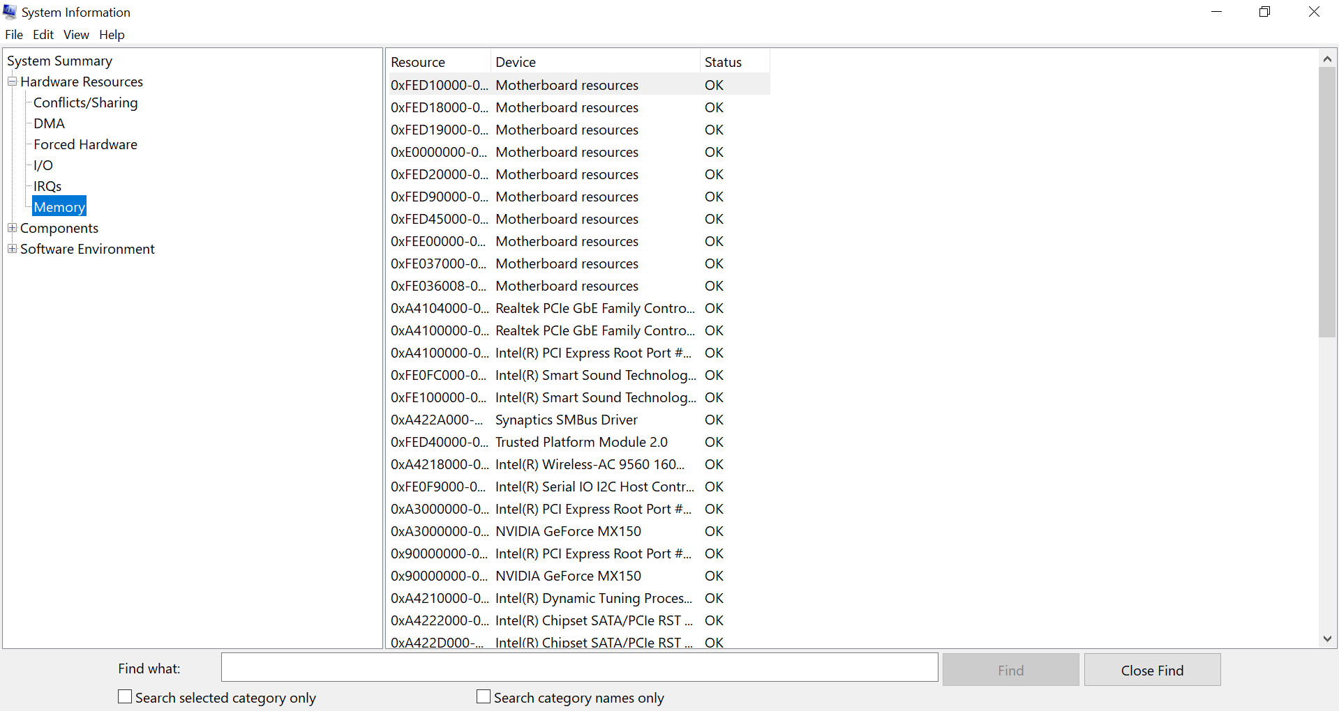

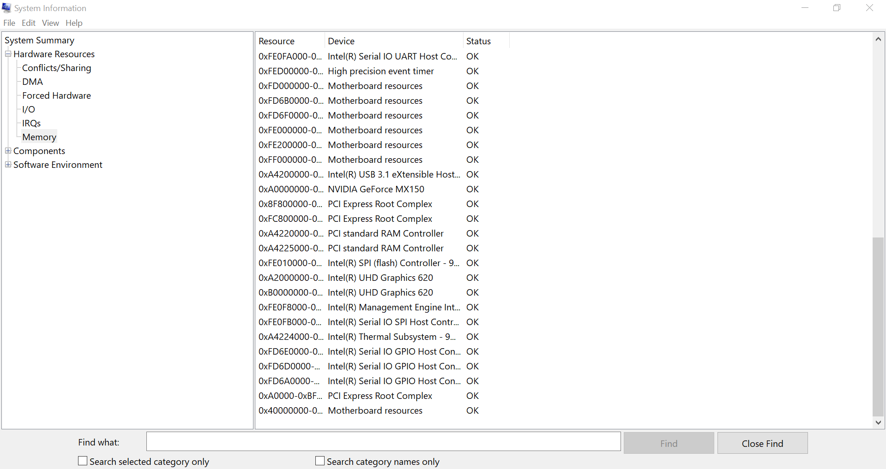

***I/O interface***

Processor 🡪 i5 8th gen   
System 🡪 Hp Pavilion 14 ce1001tx

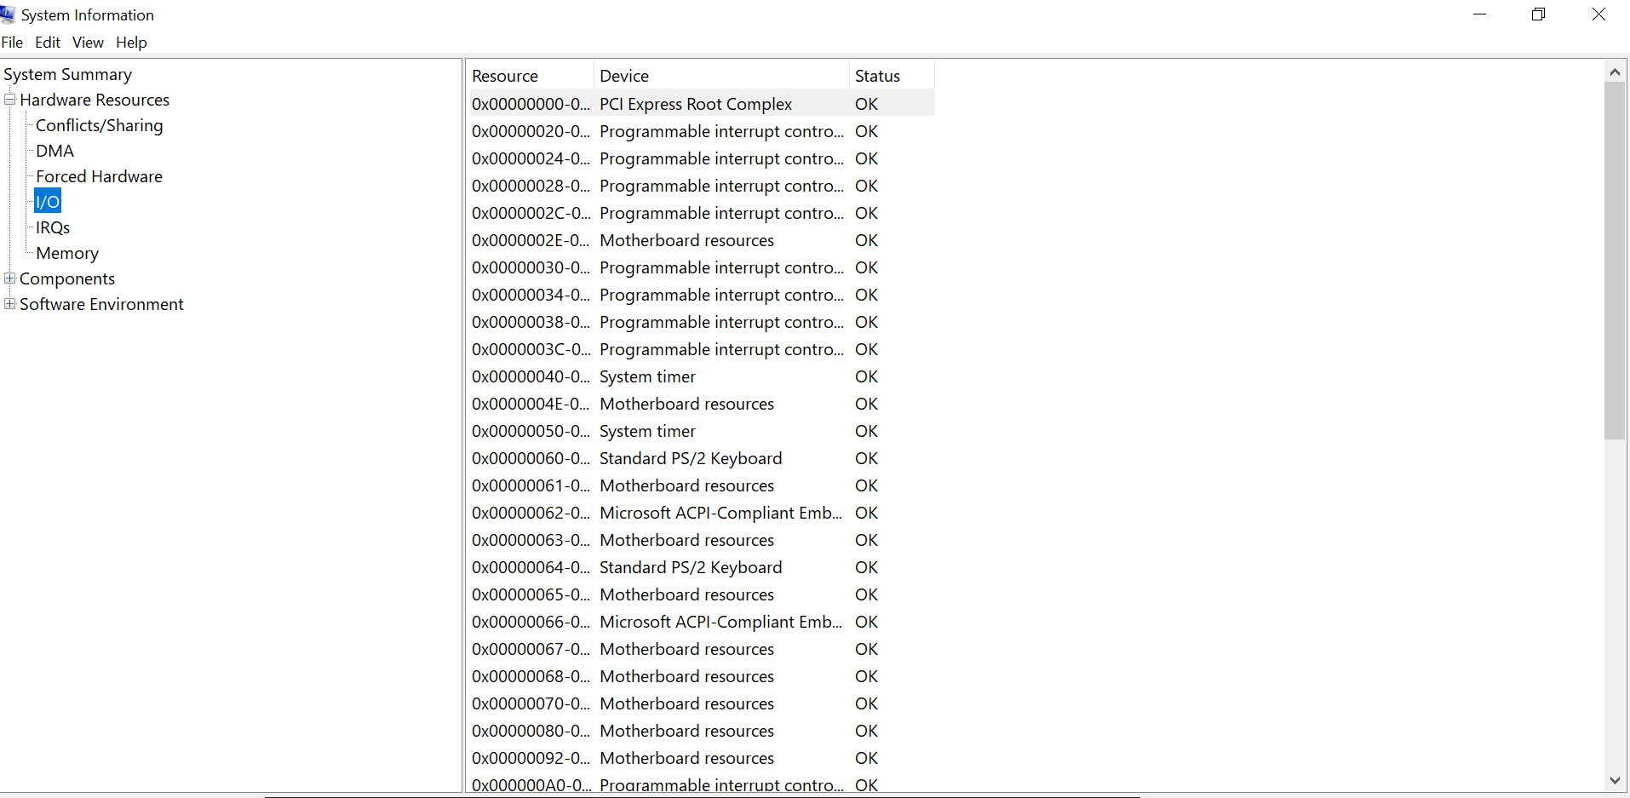

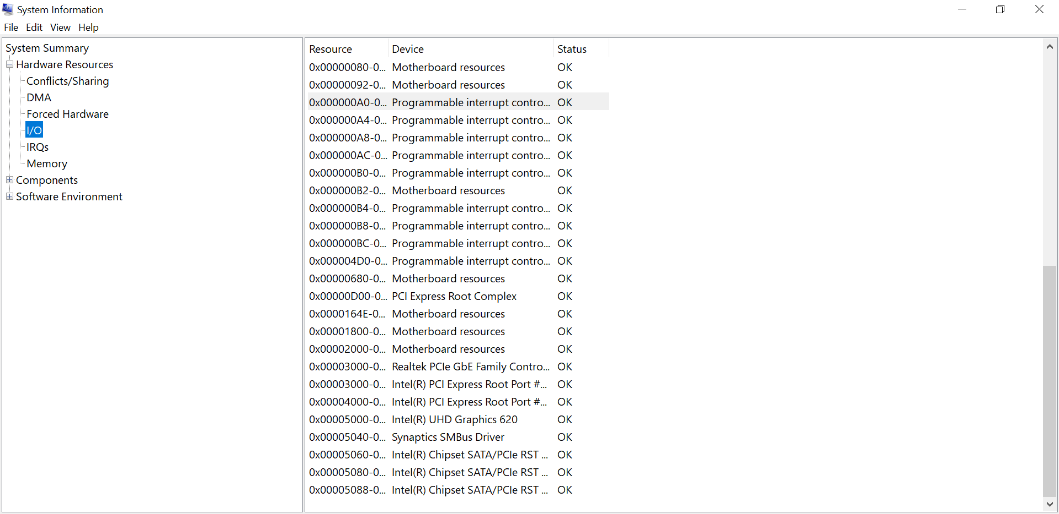

***Conflicts and Sharing Memory***

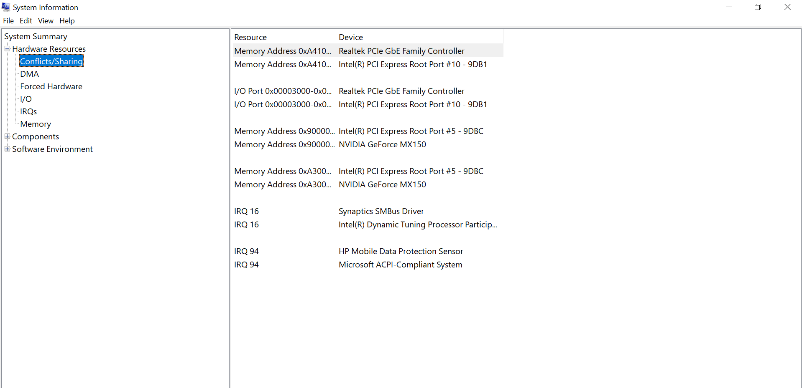

Memory design problem

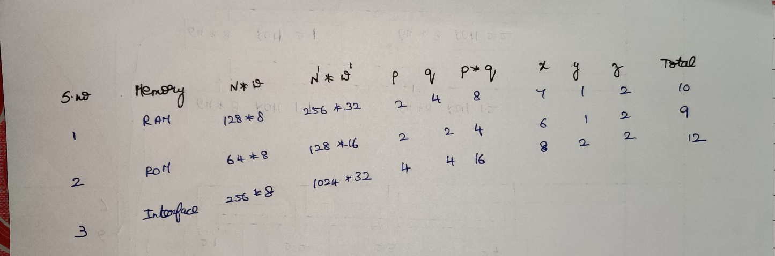

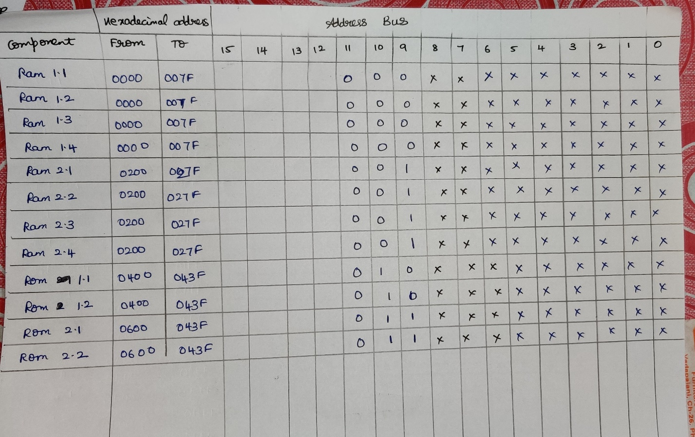

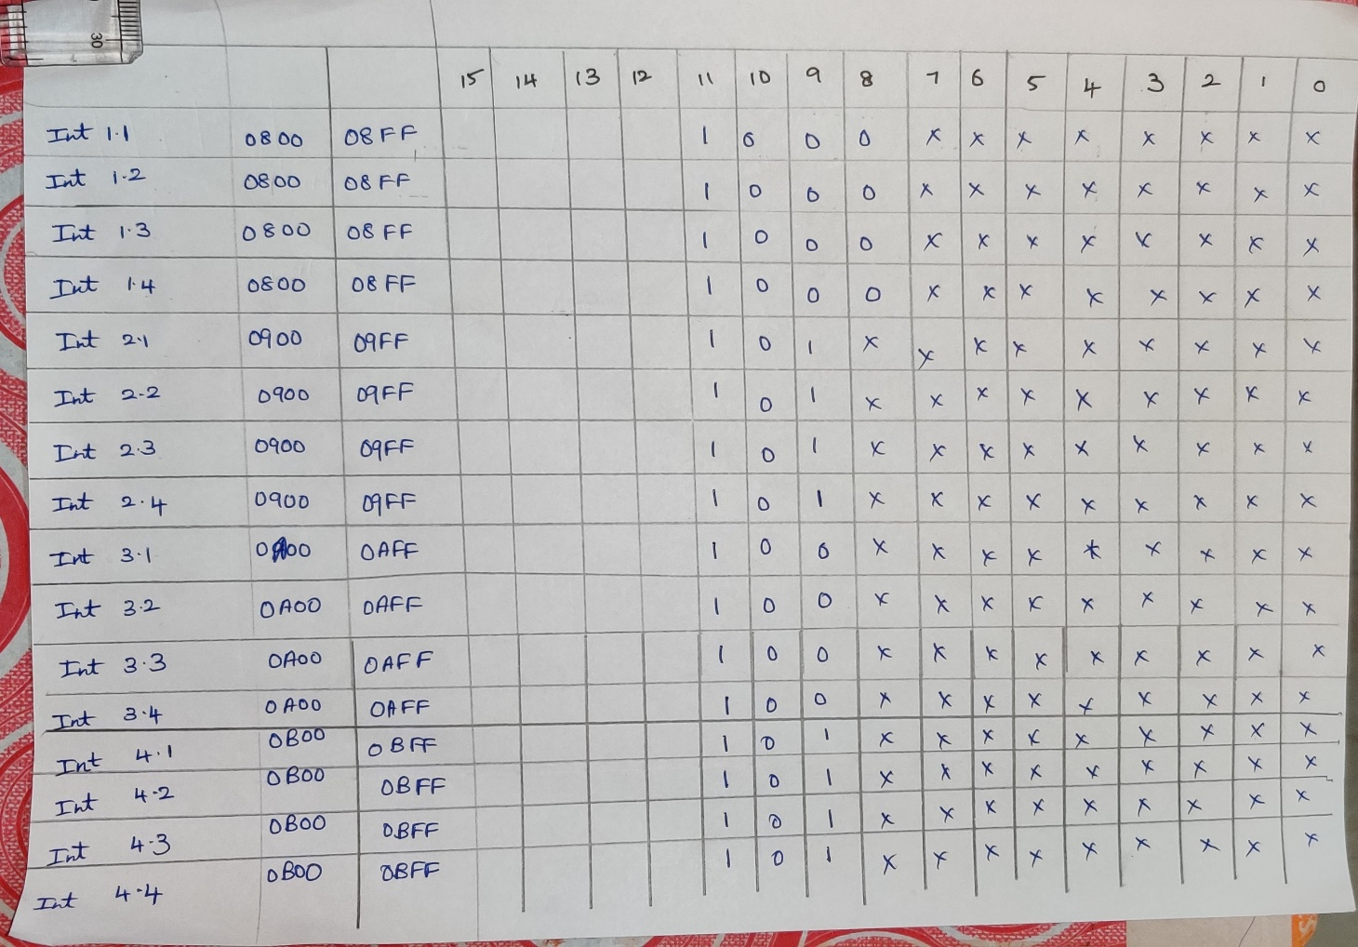

**BIOS 🡪** Basic Input/Output System

The Basic Input Output System, or BIOS, is a very small piece of code contained on a chip on your system board. When you start your computer, BIOS is the first software that runs. It identifies your computer’s hardware, configures it, tests it, and connects it to the operating system for further instruction. This is called the boot process.

Entering the BIOS setup utility allows you to change the boot process order as well as a wide variety of hardware settings. It is not recommended for an inexperienced user to change settings in the BIOS unless they are being instructed to do so by a trusted source.

Over time, limitations in BIOS led to the creation of a new firmware interface called Unified Extensible Firmware Interface, or UEFI. UEFI is very similar to BIOS, but has some advantages. It can boot from disks over 2-TB in size, has a graphical user interface with network capability, and is backward and forward compatible. UEFI is expected to eventually replace BIOS.

